ABSTRACT

The proposed Online Cab Booking project system ensures that the users can book the cab as per their requirements by logging on to the website.It allows users to book their cabs online, manage their bookings and cancel their bookings at any point of time. The users will get notified about the driver and his mobile no. to communicate with him. Regular updates are provided to the customer so that they are aware of their bookings, driver details, and booking status.

# Conditions to book cab :-

* First of all , the user need to enter all of his primary details including mobile number for communication.
* Then the interface will be taken to the next slide asking for number of passengers.
* The next slide will be asking for either 6 or 4 wheeler.
* The next two slides all are about displaying cars available.
* After these slides it will be asking for distance and displays cost accordingly.
* Final slide about payment methods either credit or debit card .
* And you are done , all the details of users will be stored in a file.

# INDEX

6

7

7

7

8

9

10

1-37

-45

46

**PAGE NO**

1

38

|  |  |  |
| --- | --- | --- |
| **S.NO** | **TITLE** |  |
| 1 | Introduction |  |
| 2 | Aim of the Project |  |
| 2.1 | Advantages & Disadvantages |  |
| 2.2 | Future Implementation |  |
| 3 | Software & Hardware Details |  |
| 4 | Class Diagram |  |
| 5 | Algorithm |  |
| 6 | Implementation |  |
| 7 | Integration and System Testing |  |
| 8 | Conclusion |  |

**INTRODUCTION**

Cab Booking System is one of the newly developed systems. “Cab Booking” Cab Booking Services and other service that are related to either the owner or the Customer. This system has been created for the role of cab booking to act as an intermediary between two clients; namely the car owner and the User . User who has the interest to book will have to register or give their details in specified website , he or she can have a full access to this system. We are here to give the best service to our clients and make ensure they get their things to happen as they wanted.As a owner of a car, you need to register your car that you want to rent out with the company. During the registration , all the details or information about the car will be fully given As a user(who books cab), you also need to register and then search for the desired car you want to book and the system will check for available car with the same match.

**JAVA :-** JAVA is an object oriented platform independent computer programming language. Java is originally developed by JAMES GOSLING and released in MAY 1995. Java is one of the most widely used programming language.

**GUI :-** Here we used GUI concept for digitalizing our project Cab Booking. It is mainly made of graphical components like buttons, labels, windows, etc. through which the user can interact with an application. GUI goes through which the user can interact with an application. GUI plays an important role to build easy interfaces for Java applications. Here we used frames, panels, buttons, labels ,Text Fields .

# AIM

The main Aim for the Cab Booking System is to manage the details of Car, Payment, Customer, Supplier ,Insurance. It manages all the information about Car, Booking, Insurance, Car .The project is totally built at administrative end and thus only the administrator is guaranteed the access. Users will be given another similar application to book a cab.

**Advantages:-** It allows users to book cabs online from anywhere on their mobile or pc.

**Disadvantages:-** It takes some time to login as the users need to give their details like email , mobile and etc..

**Future Enhancements:-** Our project , in future , can be modified with new interfaces which makes it user friendly.

# ALGORITHM

1. First of all , user need to enter all of his primary details including name, mobile number and email id.
2. Then the interface will be taken to the next slide asking for number of passengers.
3. The next slide will be asking for either 6 or 4 wheeler.
4. The next two slides all are about displaying cars available.
5. After these slides it will be asking for distance and displays cost accordingly.
6. Final slide about payment methods either credit or debit card .
7. And you are done ,all the details of users will be stored in a file.

# IMPLEMENTATION

package Project1; import java.awt.Font;

import java.awt.event.ActionEvent; import java.awt.event.ActionListener; import javax.swing.*;

public class Looking implements ActionListener

{

JFrame f;

JTextField t1,t2,t3,t4; JLabel l1,l2,l3,l4; JButton b1;

public static void main (String args[])

{

new Looking();

}

Looking()

{

f=new JFrame("WELCOME TO CAR BOOKING");

f.setLayout(null);

f.setSize(600,600); l1=new JLabel("Name");

l1.setBounds(100, 50, 100, 50); t1=new JTextField(); t1.setBounds(220, 50, 100, 50); f.add(l1);

f.add(t1);

l2=new JLabel("Mobile Number"); l2.setBounds(100, 100, 100, 50); t2=new JTextField(); t2.setBounds(220, 100, 100, 50); f.add(l2);

f.add(t2);

l3=new JLabel("Email"); l3.setBounds(100, 150, 100, 50); t3=new JTextField(); t3.setBounds(220, 150, 100, 50); f.add(l3);

f.add(t3);

l4=new JLabel("Address"); l4.setBounds(100, 200, 100, 50);

t4=new JTextField(); t4.setBounds(220, 200, 100, 50); f.add(l4);

f.add(t4);

b1=new JButton("Login Page"); f.add(b1);

b1.setBounds(200, 250, 200, 50);

b1.setFont(new Font("Times new Roman",Font.ITALIC,20)); b1.addActionListener(this);

f.setVisible(true);

}

public void actionPerformed(ActionEvent e)

{

/*String a,b,z,d; d=t4.getName(); a=t1.getName(); b=t2.getName(); z=t3.getName();*/

if (e.getSource()==b1)

{

//JOptionPane.showMessageDialog(f, "Please fill Details First");

if(t1.getText().equals("") || t2.getText().equals("") ||

t3.getText().equals("") || t4.getText().equals("") )

{

JOptionPane.showMessageDialog(f, "Please fill Details First"); System.out.println("please ");

}

else

{

new CarAvail();

}

}

/*else if (t1.getText()!=null || t2.getText()!=null || t3.getText()!=null

|| t4.getText()!=null)

{

if(e.getSource()==b1)

{

new CarAvail();

}

}*/

}

}

package Project1;

import java.awt.Font;

import java.awt.event.ActionEvent; import java.awt.event.ActionListener; import javax.swing.*;

public class CarAvail implements ActionListener

{

JFrame f; JLabel l1,l2,l3; JComboBox cb;

JRadioButton rb1,rb2; JButton b1,b2;

String d[]= {"1","2","4","6","8"};

public static void main (String args[])

{

new CarAvail();

}

CarAvail()

{

f=new JFrame("Select car on basis of Number of Passengers"); f.setLayout(null);

f.setSize(600,600);

l1=new JLabel("Passengers"); l1.setBounds(100, 50, 100, 50);

l1.setFont(new Font("Times New Roman",Font.ITALIC,20));

f.add(l1);

cb=new JComboBox(d);

cb.setBounds(220, 50, 100, 50); f.add(cb);

l3=new JLabel("Wheeler"); l3.setBounds(100, 200, 100, 50);

l3.setFont(new Font("Times New Roman",Font.ITALIC,20));

f.add(l3);

rb1=new JRadioButton("4"); rb1.setBounds(210, 200, 100, 50); rb2=new JRadioButton("6"); rb2.setBounds(320, 200, 100, 50); b1=new JButton("4 Wheeler Cars");

f.add(b1);

b1.setBounds(200, 300, 200, 50); b1.setFont(new Font("Times new

Roman",Font.ITALIC,20));

b2=new JButton("6 Wheeler Cars"); f.add(b2);

b2.setBounds(200, 400, 200, 50);

b2.setFont(new Font("Times new Roman",Font.ITALIC,20));

f.add(rb1);

f.add(rb2); b1.addActionListener(this); b2.addActionListener(this);

f.setVisible(true);

}

public void actionPerformed(ActionEvent e)

{

if (e.getSource()==b1)

{

Cars4 z=new Cars4();

}

else if (e.getSource()==b2)

{

Cars c=new Cars();

}

}

}

package Project1; import java.awt.Font;

import java.awt.event.ActionEvent; import java.awt.event.ActionListener; import javax.swing.JButton;

import javax.swing.JComboBox; import javax.swing.JFrame; import javax.swing.JLabel; import javax.swing.JTextField;

public class Cars implements ActionListener

{

JFrame f; JComboBox cb; JLabel l1,l2; JTextField t1; JButton b1;

String d[]= {"Yellow Fox","Mercedes G63 AMG 6X6","Land Rover

6×6","Willy’s Jeep"};

public static void main(String args[])

{

new Cars();

}

Cars()

{

f=new JFrame("6 Wheeler Cars"); f.setVisible(true); f.setLayout(null);

l1=new JLabel("Select Car");

l1.setBounds(100, 100, 100, 50); l1.setFont(new Font("Times New

Roman",Font.ITALIC,20));

f.add(l1);

cb=new JComboBox(d); cb.setBounds(200,75, 100, 50); f.add(cb);

/*l2=new JLabel("Enter Distance"); l2.setBounds(100, 150, 100, 50);

l2.setFont(new Font("Times New Roman",Font.ITALIC,20));

f.add(l2);

t1=new JTextField(); t1.setBounds(200, 150, 100, 50); f.add(t1);*/

b1=new JButton("Get Cost"); f.add(b1);

b1.setBounds(200, 250, 200, 50);

b1.setFont(new Font("Times new Roman",Font.BOLD,20)); b1.addActionListener(this);

f.setSize(600, 600);

}

public void actionPerformed (ActionEvent e)

{

if (e.getSource()==b1)

{

CostSix s=new CostSix();

}

}

}

package Project1; import java.awt.Font;

import java.awt.event.ActionEvent; import java.awt.event.ActionListener; import javax.swing.JButton;

import javax.swing.JComboBox;

import javax.swing.JFrame; import javax.swing.JLabel; import javax.swing.JTextField;

public class Cars4 implements ActionListener

{

JFrame f; JComboBox cb; JLabel l1,l2; JTextField t1; JButton b1;

String d[]= {"Range Rover","MG Hector","Hyundai Creta","Volkswagen Vento"};

public static void main(String args[])

{

new Cars4();

}

Cars4()

{

f=new JFrame("6 Wheeler Cars"); f.setVisible(true); f.setLayout(null);

l1=new JLabel("Select Car");

l1.setBounds(100, 100, 100, 50);

l1.setFont(new Font("Times New Roman",Font.ITALIC,20));

f.add(l1);

cb=new JComboBox(d); cb.setBounds(200,75, 100, 50); f.add(cb);

/*l2=new JLabel("Enter Distance");

l2.setBounds(100, 150, 100, 50); l2.setFont(new Font("Times New

Roman",Font.ITALIC,20));

f.add(l2);

t1=new JTextField(); t1.setBounds(200, 150, 100, 50); f.add(t1);*/

b1=new JButton("Get Cost"); f.add(b1);

b1.setBounds(200, 250, 200, 50);

b1.setFont(new Font("Times new Roman",Font.BOLD,20)); b1.addActionListener(this);

f.setSize(600, 600);

}

public void actionPerformed (ActionEvent e)

{

if (e.getSource()==b1)

{

CostFour s=new CostFour();

}

}

}

package Project1; import java.awt.Font;

import java.awt.event.ActionEvent; import java.awt.event.ActionListener; import javax.swing.JButton;

import javax.swing.JFrame; import javax.swing.JLabel; import javax.swing.JOptionPane; import javax.swing.JTextField;

public class CostFour implements ActionListener

{

JFrame f; JTextField t1;

JLabel l1; JButton b1,b2;

public static void main (String args[])

{

new CostFour();

}

CostFour()

{

f=new JFrame("Costs For 4 Wheeler"); f.setVisible(true);

f.setLayout(null);

l1=new JLabel("Dist (km)"); l1.setBounds(100, 50, 100, 50);

l1.setFont(new Font("Times New Roman",Font.ITALIC,20));

f.add(l1);

t1=new JTextField(); t1.setBounds(200, 50, 100, 50); f.add(t1);

b1=new JButton("Display Cost"); f.add(b1);

b1.setBounds(100, 250, 200, 50);

b1.setFont(new Font("Times new Roman",Font.BOLD,20)); b2=new JButton("Make Payment");

f.add(b2);

b2.setBounds(320, 250, 200, 50);

b2.setFont(new Font("Times new Roman",Font.BOLD,20)); b1.addActionListener(this);

b2.addActionListener(this); f.setVisible(true);

f.setSize(600, 600);

}

public void actionPerformed (ActionEvent e)

{

if (e.getSource()==b1)

{

String c1; int cost;

int initialcost=110; c1=t1.getText(); cost=Integer.parseInt(c1); int finalcost=cost*initialcost;

JOptionPane.showMessageDialog(f,"Cost is :"+finalcost+"rs");

}

if (e.getSource()==b2)

{

PaymentPage p1=new PaymentPage();

}

}

}

package Project1; import java.awt.Font;

import java.awt.event.ActionEvent; import java.awt.event.ActionListener; import javax.swing.*;

public class CostSix implements ActionListener

{

JFrame f; JTextField t1;

JLabel l1; JButton b1;

public static void main (String args[])

{

new CostSix();

}

CostSix()

{

f=new JFrame("Costs For 6 Wheeler"); f.setVisible(true);

f.setLayout(null);

l1=new JLabel("Dist (km)"); l1.setBounds(100, 50, 100, 50);

l1.setFont(new Font("Times New Roman",Font.BOLD,20)); f.add(l1);

t1=new JTextField(); t1.setBounds(200, 50, 100, 50); f.add(t1);

b1=new JButton("Display Cost"); f.add(b1);

b1.setBounds(200, 250, 200, 50);

b1.setFont(new Font("Times new Roman",Font.BOLD,20)); b1.addActionListener(this);

f.setVisible(true);

f.setSize(600, 600);

}

public void actionPerformed (ActionEvent e)

{

if (e.getSource()==b1)

{

String c1; int cost;

int initialcost=150; c1=t1.getText(); cost=Integer.parseInt(c1);

int finalcost=cost*initialcost;

JOptionPane.showMessageDialog(f,"Cost is

:"+finalcost+"rs");

}

}

}

package Project1; import java.awt.Font;

import java.awt.event.ActionEvent; import java.awt.event.ActionListener; import javax.swing.*;

public class PaymentPage implements ActionListener

{

JFrame f; JButton b1,b2; JLabel l1;

public static void main (String args[])

{

new PaymentPage();

}

PaymentPage()

{

f=new JFrame("Payment Page"); f.setVisible(true); f.setLayout(null); f.setSize(600,600);

l1=new JLabel("Payments"); l1.setBounds(250, 70, 100, 50);

l1.setFont(new Font("Times New Roman",Font.BOLD,20)); f.add(l1);

b1=new JButton("Credit Card"); f.add(b1);

b1.setBounds(200, 300, 200, 50);

b1.setFont(new Font("Times new Roman",Font.BOLD,20));

b2=new JButton("Debit Card"); f.add(b2);

b2.setBounds(200, 400, 200, 50);

b2.setFont(new Font("Times new Roman",Font.BOLD,20)); b1.addActionListener(this);

b2.addActionListener(this);

}

public void actionPerformed (ActionEvent e)

{

if (e.getSource()==b1)

{

CreditCard y=new CreditCard();

}

if (e.getSource()==b2)

{

DebitCard w=new DebitCard();

}

}

}

package Project1; import java.awt.Font;

import java.awt.event.ActionEvent; import java.awt.event.ActionListener; import javax.swing.*;

public class CreditCard implements ActionListener

{

JFrame f;

JLabel l1,l2,l3,l4; JTextField t1,t2,t3,t4; JButton b1;

public static void main (String args[])

{

new CreditCard();

}

CreditCard()

{

f=new JFrame("Credit Card Payment"); f.setLayout(null);

f.setSize(600,600);

l1=new JLabel("Card Number"); l1.setBounds(100, 50, 100, 50); t1=new JTextField();

t1.setBounds(220, 50, 100, 50); f.add(l1);

f.add(t1);

l2=new JLabel("Holder Name"); l2.setBounds(100, 100, 100, 50); t2=new JTextField(); t2.setBounds(220, 100, 100, 50); f.add(l2);

f.add(t2);

l3=new JLabel("Expiry"); l3.setBounds(100, 150, 100, 50);

t3=new JTextField(); t3.setBounds(220, 150, 100, 50); f.add(l3);

f.add(t3);

l4=new JLabel("Cvv"); l4.setBounds(100, 200, 100, 50); t4=new JTextField();

t4=new JPasswordField(); t4.setBounds(220, 200, 100, 50); f.add(l4);

f.add(t4);

b1=new JButton("Make Payment"); f.add(b1);

b1.setBounds(200, 250, 200, 50);

b1.setFont(new Font("Times new Roman",Font.BOLD,20)); b1.addActionListener(this);

f.setVisible(true);

}

public void actionPerformed (ActionEvent e)

{

String a,b,z,d; d=t4.getText(); a=t1.getText();

b=t2.getText(); z=t3.getText();

if (e.getSource()==b1)

{

if (a.equals("") || b.equals("") || z.equals("") ||

d.equals(""))

{

JOptionPane.showMessageDialog(f,

"Please fill Details First");

}

else

{

JOptionPane.showMessageDialog(f,"PAYMENT SUCCESSFULL"+"\n"+"YOU'LL RECIEVE A CONFIRMATION MAIL SOON");

}

}

}

}

package Project1; import java.awt.Font;

import java.awt.event.ActionEvent; import java.awt.event.ActionListener; import javax.swing.*;

public class DebitCard implements ActionListener

{

JFrame f;

JLabel l1,l2,l3,l4;

JTextField t1,t2,t3,t4; JButton b1;

public static void main (String args[])

{

new DebitCard();

}

DebitCard()

{

f=new JFrame("Credit Card Payment"); f.setLayout(null);

f.setSize(600,600);

l1=new JLabel("Card Number"); l1.setBounds(100, 50, 100, 50); t1=new JTextField(); t1.setBounds(220, 50, 100, 50); f.add(l1);

f.add(t1);

l2=new JLabel("Holder Name"); l2.setBounds(100, 100, 100, 50); t2=new JTextField();

t2.setBounds(220, 100, 100, 50); f.add(l2);

f.add(t2);

l3=new JLabel("Expiry"); l3.setBounds(100, 150, 100, 50); t3=new JTextField(); t3.setBounds(220, 150, 100, 50); f.add(l3);

f.add(t3);

l4=new JLabel("Cvv"); l4.setBounds(100, 200, 100, 50); t4=new JTextField();

t4=new JPasswordField(); t4.setBounds(220, 200, 100, 50); f.add(l4);

f.add(t4);

b1=new JButton("Make Payment"); f.add(b1);

b1.setBounds(200, 250, 200, 50);

b1.setFont(new Font("Times new Roman",Font.BOLD,20)); b1.addActionListener(this);

f.setVisible(true);

}

public void actionPerformed (ActionEvent e)

{

String a,b,z,d; d=t4.getText(); a=t1.getText(); b=t2.getText(); z=t3.getText();

if (a.equals("") || b.equals("") || z.equals("") || d.equals(""))

{

JOptionPane.showMessageDialog(f, "Please fill Details First");

}

if (e.getSource()==b1)

{

if (a.equals("") || b.equals("") || z.equals("") || d.equals(""))

{

JOptionPane.showMessageDialog(f, "Please fill Details First");

}

else

{

JOptionPane.showMessageDialog(f,"PAYMENT SUCCESSFULL"+"\n"+"YOU'LL RECIEVE A CONFIRMATION MAIL SOON");

} } } }

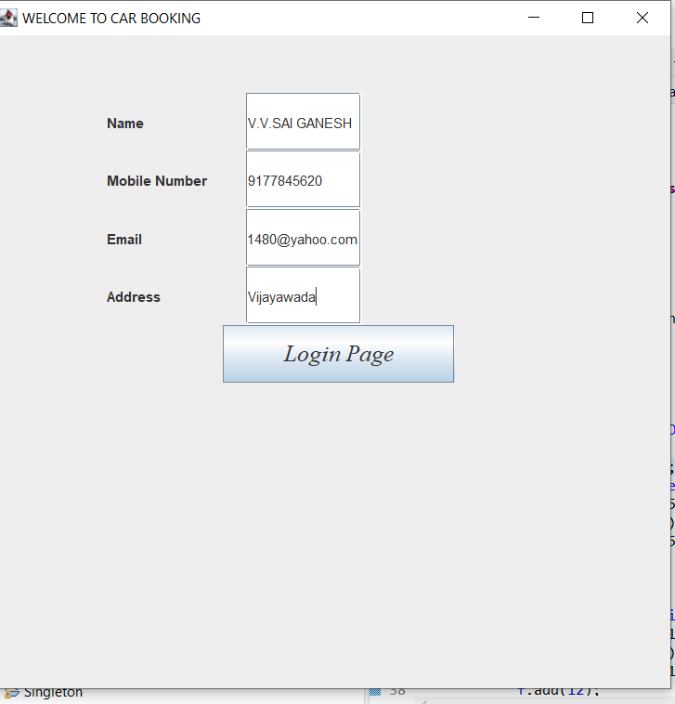

# INTEGRATION AND SYSTEM TESTING

OUTPUTS

Screen Shots:

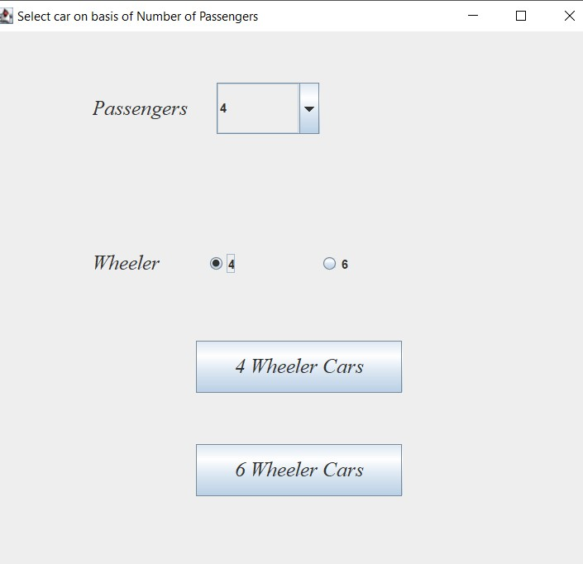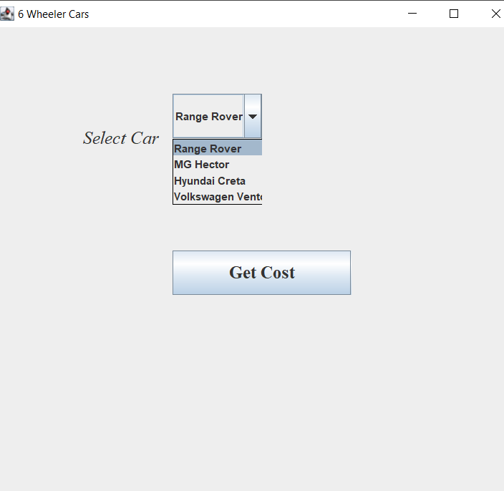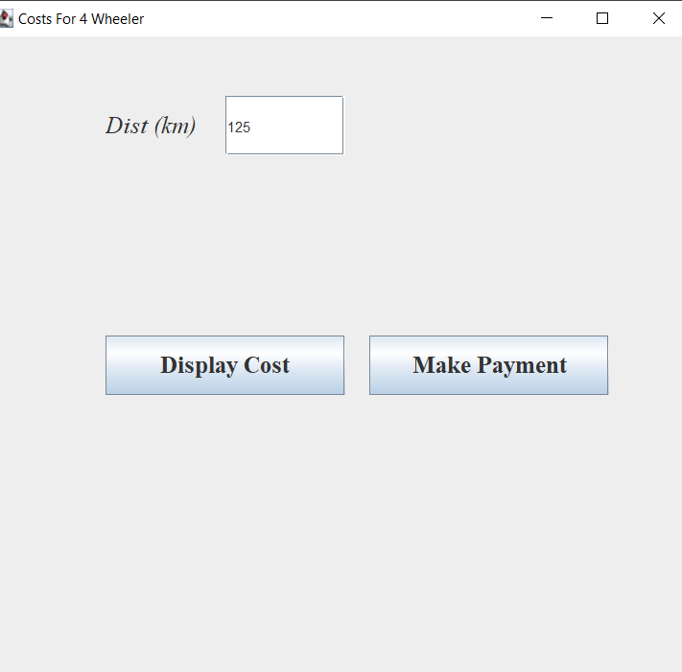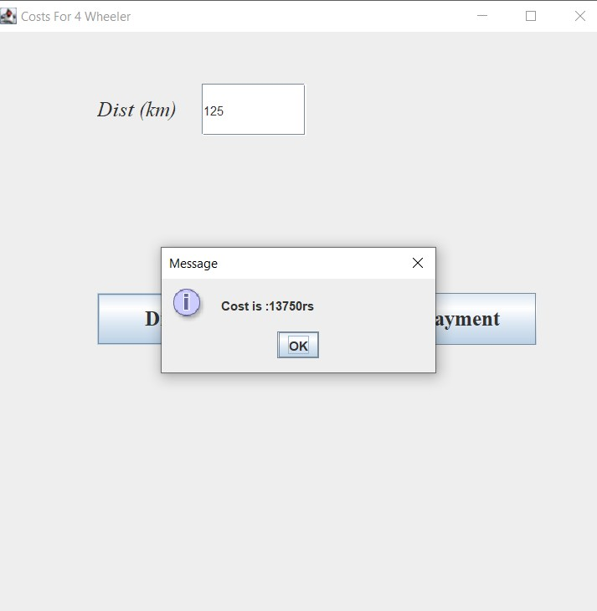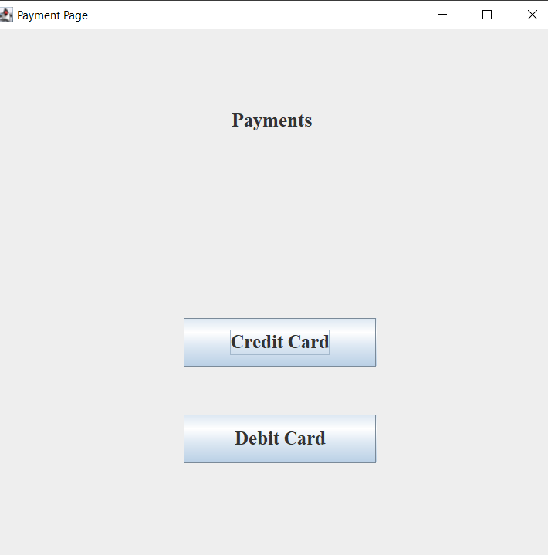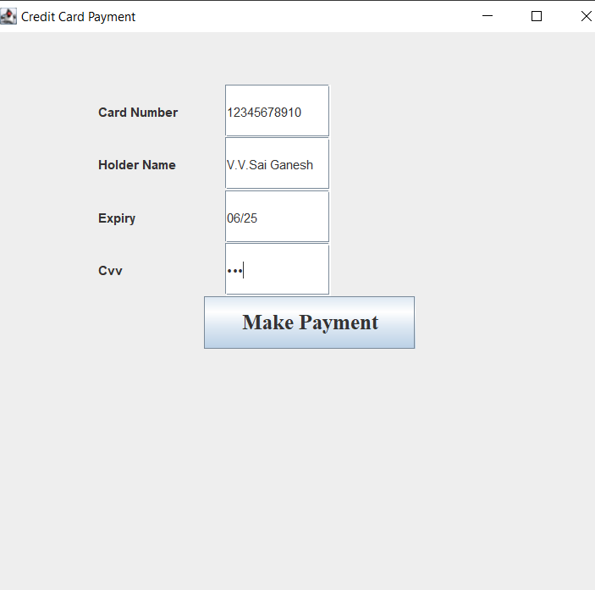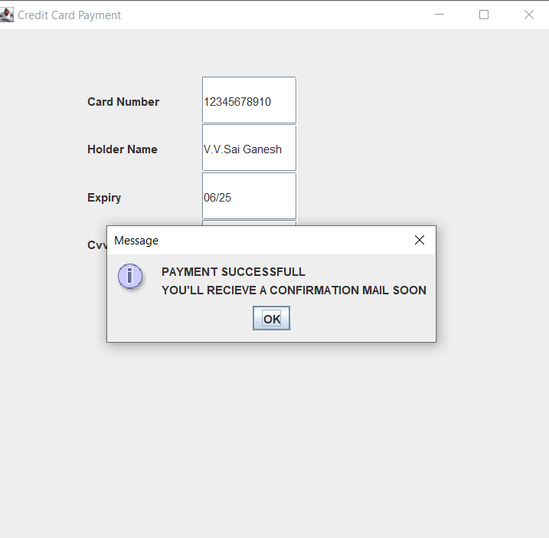

# CONCLUSION

By this project we had conclude that the system will be able to serve as a web base application when it is finally developed, where these small upcoming companies can make use of it to publish their services in a wide range and also help the company to manage their service more effectively. Our project , in future , can be modified with new interfaces which makes it user friendly.